**Task 1:**

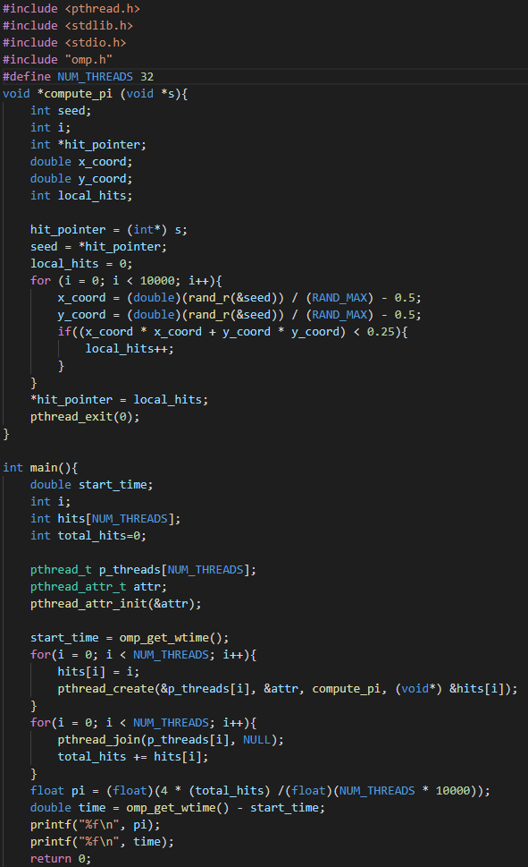

4 threads:



8 threads:



16 threads:



32 threads:



**Task 2:**

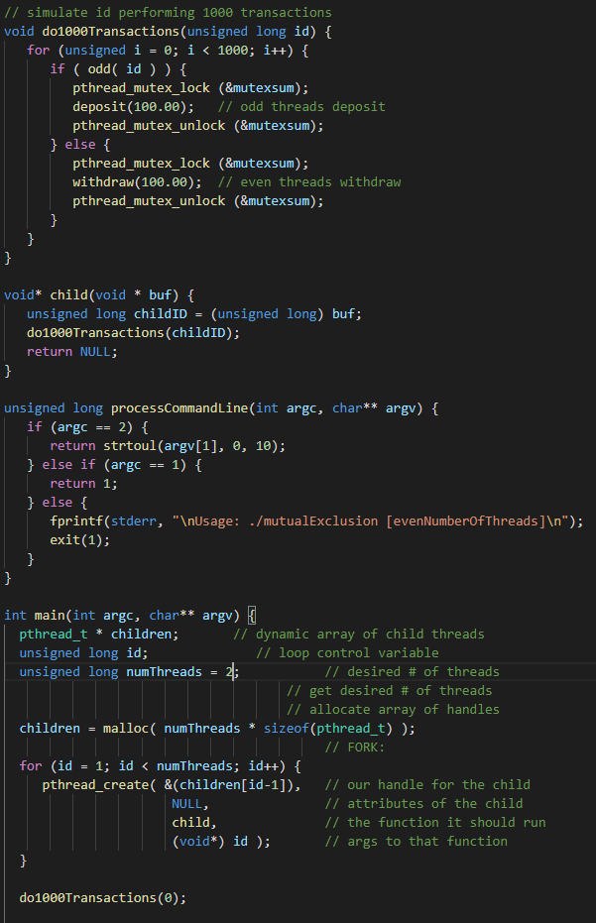









A line within the original code was modifying the number of threads used to 1, which would cause the bank account balance to subtract to $-100000.00. Furthermore, each thread had access to the bank account balance in the header file. Using mutex to lock the variable for consistency to the bank account balance and removing the line in the main function fixes the problem.

**Task 3:**

I have no idea.